Bottle Buddy Biography Project
Projects due: Friday February 24, 2017
4 Step Project:
- Research a person
- Make a Bottle Buddy
- Write a Riddle
- Share your work.

- Research a famous person- it may be someone famous from history, or a current person. Read biographies and/or articles about your person. You need to have at least three reliable sources.
  - A biography is simply the story of a life. Biographies analyze and interpret the events in a person's life. They try to find connections, explain the meaning of unexpected actions or mysteries, and make arguments about the significance of the person's accomplishments or life activities. Biographies are usually about famous or infamous people, but a biography of a historical person can tell us a lot about the particular time and place they lived in.
  - First, Find out the basic facts of the person's life. You can use the internet or books as resources. Then, think about what else you would like to know about the person, and what parts of their life you want to learn most about. Some questions you might want to think about including are:
    - What makes this person special or interesting?
What kind of effect did he or she have on the world? other people?
What are the adjectives you would most use to describe the person?
What examples from their life illustrate those qualities?
What events shaped or changed this person's life?
Did he or she overcome obstacles? Take risks? Get lucky?
Would the world be better or worse if this person hadn't lived? How and why?
- Write a Biography about your person-
  - Write your biography, making sure to have an introduction that draws in the reader, and interesting and informative body and a thoughtful conclusion.
  - Biographies are usually written in chronological order and focus on accomplishments during their life.

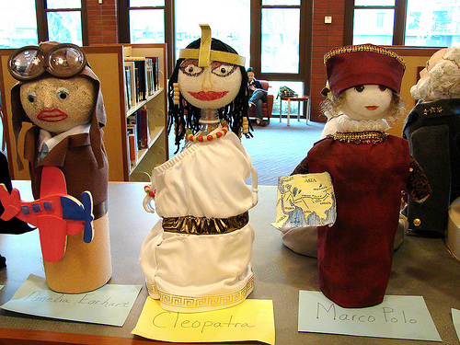
- Make a bottle buddy -use a 2-liter bottle for the body and a painted 4” Styrofoam ball (found at Hobby Lobby, Wal-Mart or other craft stores) for the head. Fill the bottom with 2 inches of sand or dirt. Make the bottle look like your person. To make your bottle like your person use any material available: felt, paint, fabric, rocks, sticks, hats, construction paper, aluminum foil, etc. to create their costume and props. Your teacher at school will have materials you can use as well if you need some. Also if you have extra bottles, balls or supplies please bring them in!

- Create a biography riddle. Include at least 10 clues either typed or written very neatly with pen. Try to choose things that will surprise people. Example below:
Who am I?
I had size 14 feet.
I had a great sense of humor and I like to make jokes.
I was colorblind.
I almost drowned when I was a boy, but was saved by a neighbor.
I was afraid of the dentist.
I was President of the United States of America.
I was the only US President to hold a patent (I liked to invent things).
I was a lawyer.
I was born in 1809 in a log cabin.
I had a sister named Sarah.
Who am I?

Abraham Lincoln

- Bring your bottle buddy to school on Friday February 24. Be ready to share your bottle buddy, riddle, and presentation with other students in our building.

- Contact Mr. Maben if you have any questions at omaben@wcpss.net or classdojo

- - - - - - - - - - - - - - - - - - - - - - - - - - - - - - - - - - - - - - - - - - - - - - - - - - - - - - -

*Please remove this slip, sign it and return it to school to show that you are aware of this literacy project.

Student Name: _______________________________ Class: _____________________

Parent Signature: _______________________________ Date:___________________

